
Mayumi Haven
Business Case


Chenylle Geronimo
10630217

Contents
Web Application Idea 2
Hotel Web Application: 2
Name: 2
Description: 2
Objectives: 2
Good Navigation: 2
User Privileges: 2
Real-time User Interaction/Communication: 2
Security: 2
Cloud Deployment: 3
Business Case: 3
Background: 3
Needs: 3
Customer Needs: 3
Hotel Staff Needs: 3
Target Audiences 3
Couples: 4
Families: 4
Solo Travellers: 4
Business Travellers: 4
Competitors Web Applications 4
Clayton Hotel (4 Star) 4
Strengths: 4
Any Improvements?: 7
The Address Connolly Hotel (4 Star) 7
Strengths: 7
Cons: 7
Hotel Riu Plaza (4 Star) 7
Strengths: 7
Cons: 7
Comparison: 7
Structural Diagram 8
Database Diagram 8
Technologies Used 9
Maintenance 9
Search Engine Optimisation 9
List of Browsers Used to View 9
Responsiveness: 9
Strengths And Weaknesses of Mayumi Haven 10
Strengths: 10
Cons: 10
References 10

Web Application Idea

Hotel Web Application:

Name:
Mayumi Haven

Description:
Mayumi Haven is a web application for the Mayumi Haven hotel. Users are able to book rooms to stay and create accounts to see previous bookings. It will provide a simple interface for users to easily navigate the application where they can make these bookings and learn more information about the hotel.

Objectives:

Good Navigation:
This application provides an aesthetic interface for users where they are able to easily navigate through the application. They are able to make bookings and find the information they need without spending too much time searching through the web application.

User Privileges:
- Customers must sign up to become a Mayumi member for free to access their booking history and edit account details such as their phone number.

Real-time User Interaction/Communication:
The web application will include form validation and room availability (Javascript). There will be a real-time contact form that allows customers to send a message to the hotel for any questions or issues the customer may have. The hotel admin will be notified whenever they receive a message and will email them back with a response.

Security:
In addition to the user privileges for the security. The passwords and card details are encrypted to ensure secure transactions and to prevent any personal information from being accessed by hackers.

Cloud Deployment:
The web application will be deployed on Amazon Web Services (AWS) using Elastic Beanstalk for easy scalability during peak seasons. It also provides reliability as the cloud provides disaster recovery.

Business Case:

Background:
Mayumi Haven is a newly built hotel in Dublin, Ireland. Mayumi Haven requires a web application as it is essential for a new hotel to gain customers within Ireland and globally. Some customers may face challenges with navigating through other hotels’ websites. There may be difficulties with booking or unclear pricing and availability. By utilising a seamless application, Mayumi Haven is able to compete with existing and upcoming hotels within Dublin.

Needs:
The application must allow users to easily and efficiently make bookings remotely without having to make any phone calls to the hotel. The web application requires an aesthetic interface with good navigation to encourage user interaction. Contact options will be provided to ensure that all customer queries are addressed. The web application will be deployed on the cloud as it provides reliability, scalability and security.

Customer Needs:
- Able to track their confirmed room bookings.
- Constant communication with hotel organisers to ensure all questions and concerns are addressed.
- High security for payments and to keep their personal information safe.
- Easy booking from anywhere on all devices. Bookings can be modified through the application
- Flexible booking changes and cancellation policy. Customers can make booking changes/cancellations but it must be 48 hours prior to the booking date. Otherwise, there will be a cancellation fee.
- Customers can leave a feedback based on their experience with the application and the hotel.
- Provide real-time availability and accurate pricings
- Given a choice to receive notifications for booking updates, messages, promotions, etc..

Hotel Staff Needs:
- Reception staff must be able to view room stay bookings.
- Constant communication with customers.
- Notified whenever a customer sends a message or email and feedback.

Target Audiences

Our target audience includes:
- Couples
- Families
- Solo Travellers
- Business Travellers

Couples:
To attract couples to stay at Mayumi, we are providing a ‘Romance Bundle’ which is an extra feature addon that couples can book on our web application. It includes a bouquet, chocolates and a bottle of prosecco. This is suitable for couples who are spending their anniversary at a hotel. There is also ‘Birthday Surprise’ which includes a balloon, chocolates and a bottle of prosecco.

Families:
We have family rooms offers to attract families to stay at our hotel. We are providing cribs and cradles (upon request) as well as keeping basic necessities such as diapers, toothbrushes, toothpaste and wipes at the front desk.

Solo Travellers:
For solo travellers it is extremely important to ensure that they feel safe and comfortable in our hotel. There is a 24/7 reception desk to assist guests at any time. The corridors must be well-lit and key cards must be secure for each room as well as an extra lock inside. It is important to encourage solo travellers to socialise. We have a bar and restaurant where they can meet other travellers.

Business Travellers:
We must encourage business travellers who come to Dublin often to stay at our hotel. They can keep track of their booking history by signing in. We provide discounts for members who frequently stay at our hotel as a rewards programme. High speed internet connection is important for business travellers because it is essential for their work.

Competitors Web Applications

Clayton Hotel (4 Star)

Strengths:
- Aesthetic User Interface:
  - Nice choice of colours and the font is clearly visible which is good for customers with visual impairments.
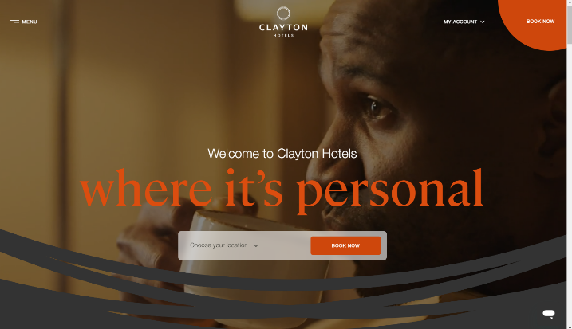
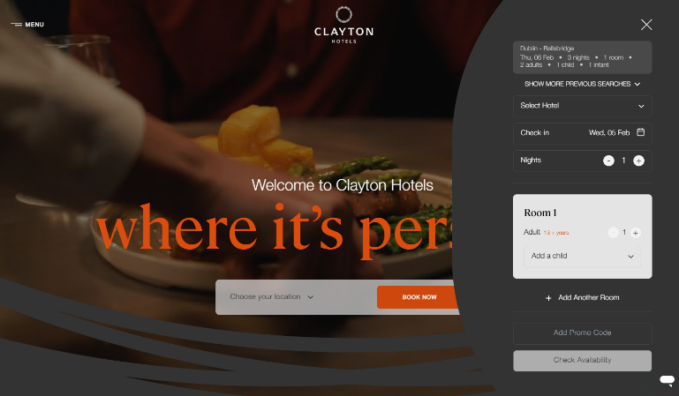
- Good Site Navigation:
  - The home page clearly displays 2 booking buttons which both show the same pop-up on the right-hand side to enter room booking details.

- Very Informative:
  - You can click on each room and a pop-up appears to provide more details such as free wifi. It informs the customer about the free cancellation.
- Allows Personalisation:
  - Once you click on the button for the room you want, it allows you to personalise it.
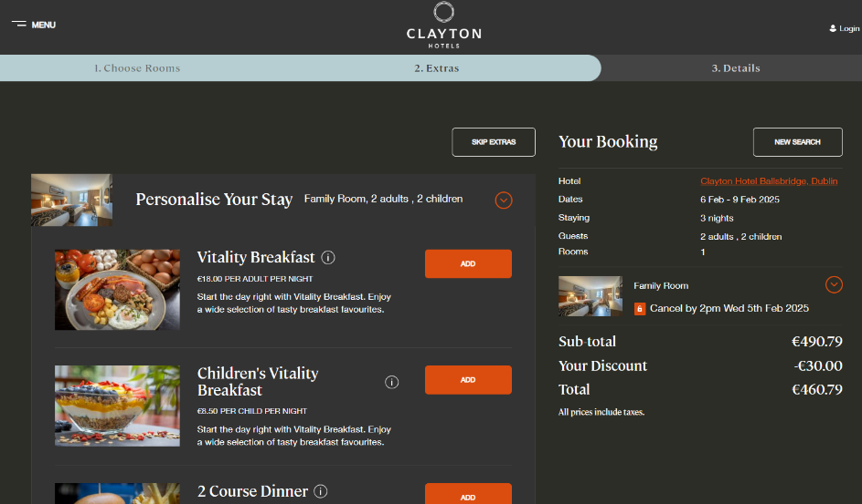
- Lots of Options:
  - Once the customer clicks the ‘add’ button, a pop-up appears and gives the user options for which night they want to add the extras (vitality breakfast, 2 course dinner, etc…).
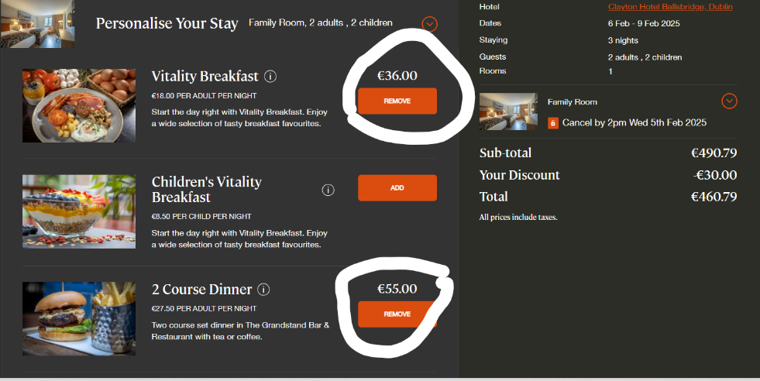
  - It then displays the total of the added features and you can click the ‘next’ button to redirect you to a ‘details’ page where the booking summary is updated according to the total price of the extras.
- High security:
  - At the bottom of the page are the payment details which are encrypted and secure.
- Form Validation:
  - If the customer has entered any wrong form details or left spaces blank then it doesn’t finalise the booking and displays the required information below each text box in red.
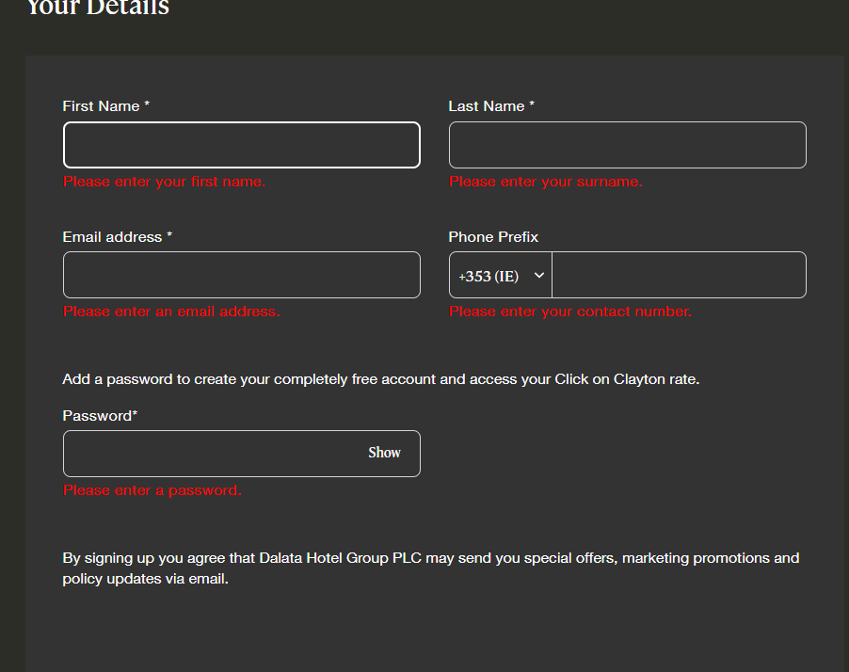
- Excellent Customer Communication:
  - There is a live chat for customers to easily communicate with the hotel staff.

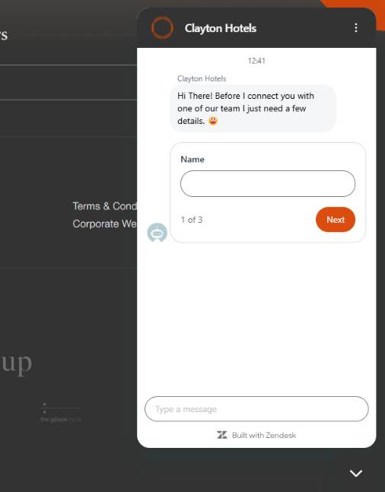

Any Improvements?:
- Loyalty Scheme:
‘Clayton’ doesn’t do much promotions for members. There should be an option to sign up on the home page.
- The screen is also quite dark, which may make it more difficult for people with visual impairments.

The Address Connolly Hotel (4 Star)

Strengths:
A lot of the strengths of this website are similar to the previously mentioned hotel such as aesthetic user interface, personalisation, etc.. However, this web app effectively encourages users to join their membership. It gives 10% off their next booking and sends discount codes to their email if they sign up and join their mailing list.

Cons:
Some of the text was quite small and there wasn’t much of a contrast between the font colour and background colour which may make it difficult for users with visual impairments.

Hotel Riu Plaza (4 Star)

Strengths:
Its strengths are similar to the other two applications with the aesthetic user interface and good site navigation
- Strong Functionality:
  - ‘Riu Plaza’ has almost everything customers are looking for within the home page. It allows customers to view their reservation without signing in. It also provides multiple languages making it accessible for customers globally. It also displays contact options and FAQs for customers with any queries or issues. Additionally, It also has a live chat option which enables customers to receive real time information.

Cons:
One disadvantage for this website is that you cannot book for dinners or any other feature to personalise your stay while booking the room itself. Meanwhile in ‘Clayton’ and ‘The Address’, it allows users to book saunas/spas, dinners, early check-ins and late check-outs and changes the final price based on the customer's request.

Comparison:
Out of the three websites, the home page functionality of ‘Riu Plaza’ is the best because of how easy it is to find all the options and information you need within the home page. However, ‘Clayton’ and ‘The Address’ allows customers to personalise their stay and book any additional features. ‘Clayton’s’ interface is more aesthetically pleasing in comparison to ‘Riu Plaza’ and ‘The Address’. The colour choices made ‘Clayton’s’ interface stand out. I liked how ‘Riu Plaza’ and ‘The Address’ promoted customers to become members by showing the membership rates and discounts. It encourage customers to come back Overall, all these websites are good and I will make sure to add in the features that I liked from each website to ‘Mayumi Haven’s’ web application.

Structural Diagram
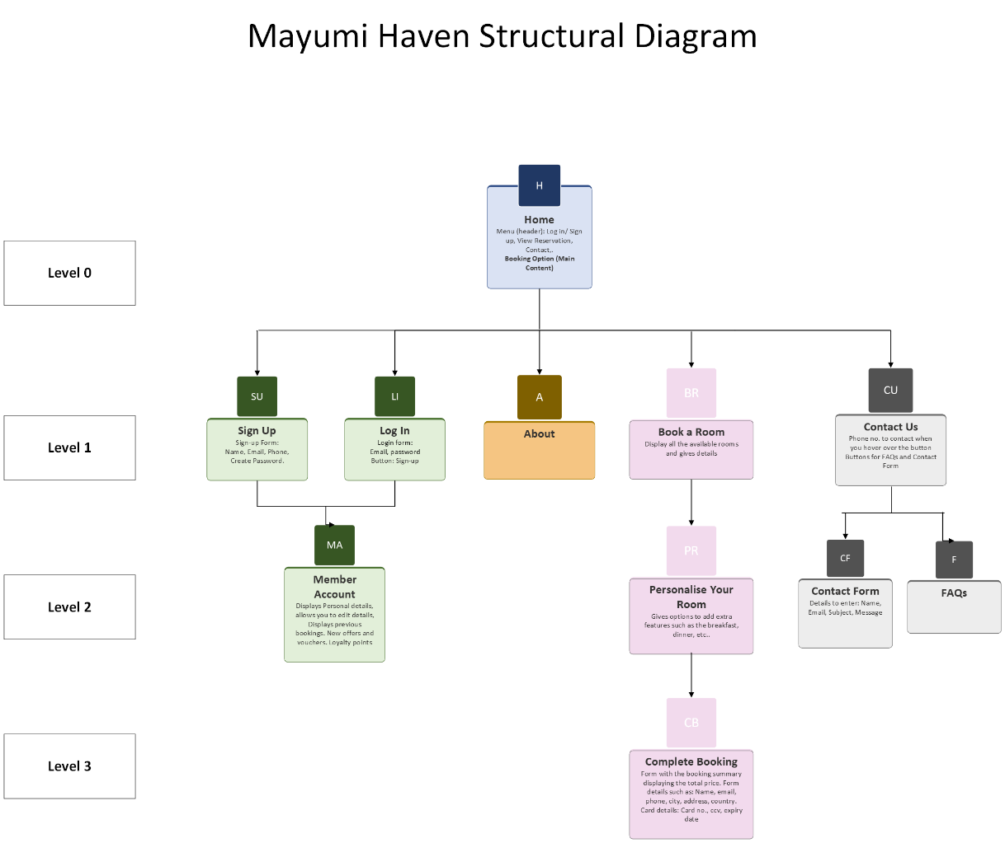

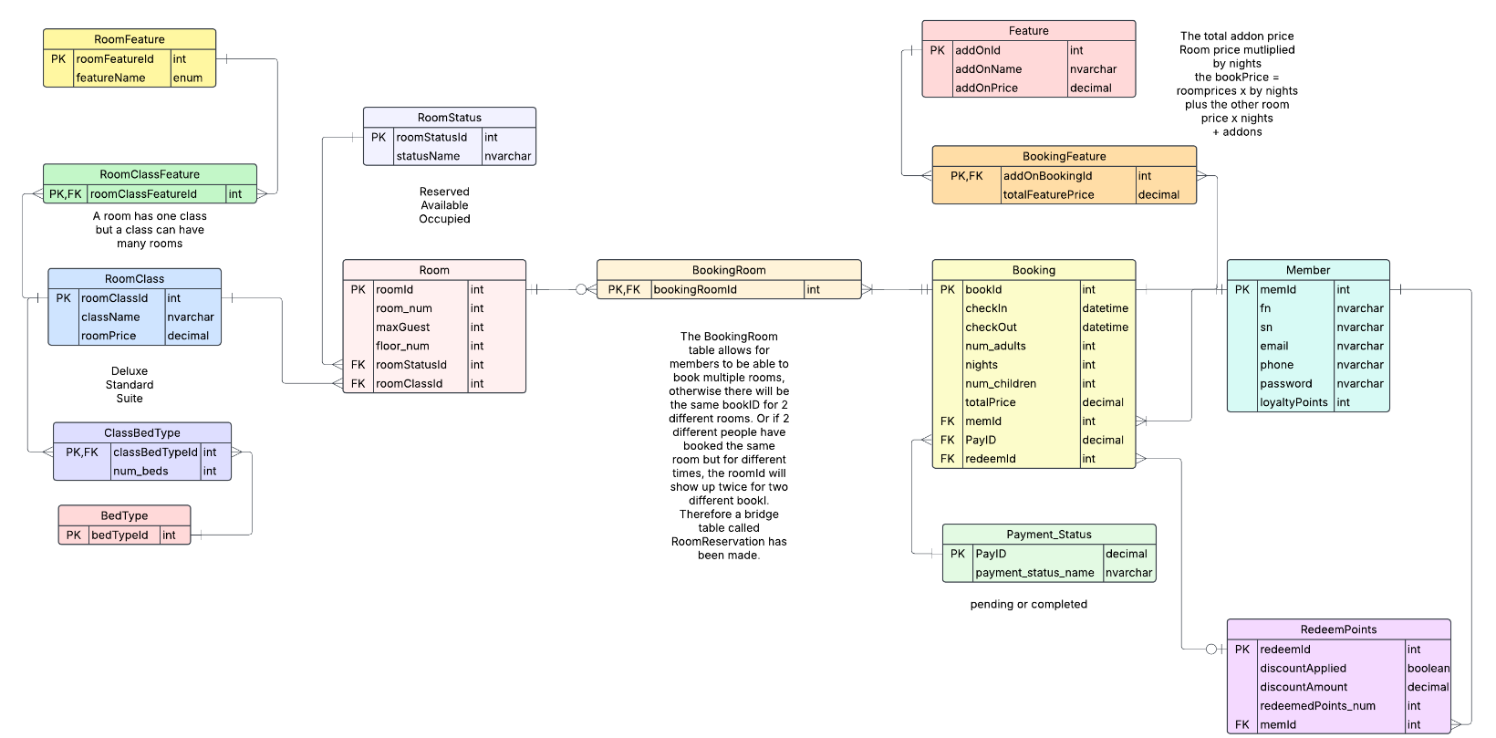
Database Diagram

Technologies Used
- Visual Studio 2022 to create the ASP.NET web forms .NET Framework.
- SQL database in Visual Studio to store the information.
- C# Programming language.
- Javascript for dynamic pages. To improve user experience.
- Frontend:
  - HTML
  - CSS for design
  - Bootstrap
- Cloud: Amazon Web Services (AWS) Elastic Beanstalk.

Maintenance
- It is important to ensure that Mayumi web application’s software is up to date. This maintains the performance and security of the application. It helps to ensure compatibility with other software and hardware. Additionally, it helps to fix any bugs from previous versions.
- We are regularly creating backups for the application for disaster recovery. This keeps our application safe from any unforeseen issues such as data loss, breaches, etc.. AWS also provides cloud backup and disaster recovery features.
- We are also carrying out maintenance testing to discover any bugs or errors in the code. This helps to address any issues users may face with the website.
- Security testing is important for maintaining the web app. This is imperative to ensure the safety of our users and their data. Regular security testing checks for any vulnerabilities and risks.

Search Engine Optimisation
I added these for search engine optimisation:
- Meta titles for each of the pages.
- Meta description & keywords.
- Header tags.
- SEO friendly URLs for the images such as “images/DeluxeRoom.png”.
- Alt texts for the images which also helps with accessibility.

List of Browsers Used to View
- Google Chrome
- Firefox
- Microsoft Edge

Responsiveness:
I ensured that the web application is still suitable for smaller screens using CSS. I added toggles and scroll bars and changed the font size depending on the screen size.
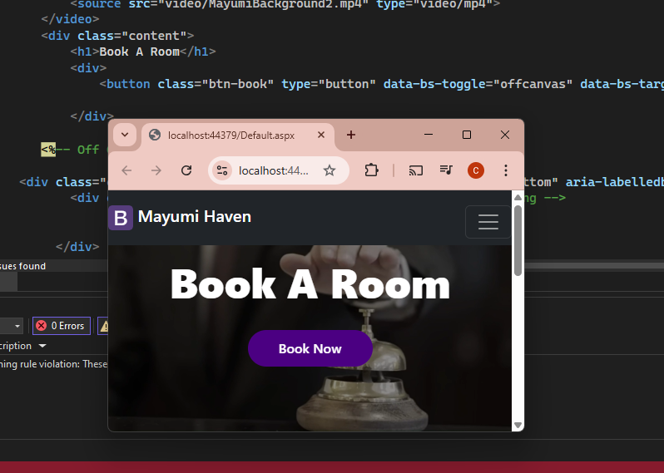

Strengths And Weaknesses of Mayumi Haven

Strengths:
- Aesthetic user interface:
  - I kept the same colour scheme between all the pages and the buttons.
  - I ensured that the font colour and background colour have a high contrast for users with visual impairments to be able to access the site. Additionally I added alt texts to the images to help with site accessibility.
- Good site navigation:
  - I ensured good site navigation by adding all the links that the user needs at the top of the page in the menu.
  - I put the booking form in the home page as the main content so that it is easy for users to find and book a room. There are also two links that open the booking form, the ‘Book’ menu link and the ‘book now’ button.
- Allows personalisation:
  - Mayumi Haven web application allows users to personalise their room bookings and add the prices of these addons to the total booking price.
- Form Validation:
  - This aids in user experience.

Cons:
- Not enough membership promotions
  - There are no discounts given on the website or loyalty scheme.
- Requires more information and options such as a booking form for the restaurant or spa.

References
- Clayton Hotels. (n.d.). Hotels in Ireland & the UK | Hotel Deals. [online] Available at: https://www.claytonhotels.com/. [Accessed: 7 April 2025]
- Elphick, D. (2015). How To Attract Business Travelers to Your Small Property. [online] Little Hotelier. Available at: https://www.littlehotelier.com/blog/running-your-property/how-to-attract-business-travelers-to-your-small-property-or-bed-breakfast/. [Accessed: 7 April 2025]
- Google (2025). Advantages Of Cloud Computing. [online] Google Cloud. Available at: https://cloud.google.com/learn/advantages-of-cloud-computing.https://testsigma.com/blog/test-maintenance/ [Accessed: 7 April 2025]
- Moradov, O. (2021). Security Testing: Types, Tools, and Best Practices. [online] Bright Security. Available at: https://brightsec.com/blog/security-testing/.https://uphotel.agency/hotel-website-maintenance-tasks/ [Accessed: 7 April 2025]
- Riu.com. (2025). RIU Hotels & Resorts · Official Website · RIU.com. [online] Available at: https://www.riu.com/en. [Accessed: 7 April 2025]
- The Address Connolly. (2025). Address Connolly | Best Hotels In Dublin | Hotels In Dublin City Centre. [online] Available at: https://www.theaddressconnolly.com/ [Accessed 7 Apr. 2025].
- Turton, A. (2024). How Hotels Can Cater to Solo Travellers. [online] Trginternational.com. Available at: https://blog.trginternational.com/hotels-solo-travellers. [Accessed 7 Apr. 2025].
- Welcome Family. (n.d.). How can I attract families to my hotel? [online] Available at: https://welcomefamily.com/en/blog/how-can-i-attract-families-to-my-hotel.html. [Accessed 7 Apr. 2025].

